POSTHUMAN
Biography:
UK veterans Posthuman are cousins Josh Doherty & Richard Bevan.
Writing music together as teenagers in the late 90s, their debut album ‘Uncertainty of the Monkey’ was named by Pitchfork as “one of the best electronic albums of 2001”. They made a name for themselves playing at Warp Records’ NESH and Skam’s COMPRESSION parties in the late 90s/early00s, then founding their own label Seed Records and hosting events with the likes of Aphex Twin and Goldfrapp in an abandoned tube station in London, before starting their own famous clubnight ‘I Love Acid’ in 2007
Now regarded as spearheads of the modern UK Acid House scene alongside the likes of Ceephax Acid Crew, Paranoid London, Luke Vibert and Jerome Hill. The duo remain DJ residents & hosts at ‘I Love Acid’ – with nearly 200 events now since 2007 - Current club residencies in London & Glasgow in the UK, Brooklyn & Chicago in the USA, as well as dozens of other cities across Europe, the UK and USA, and festivals like Bangface, Bloc, Shindig and more. ‘I Love Acid’ won DJ Magazine’s Best British Club Event award in 2019. They also run a label of the same name, which has sold out over 25 records in a row, often in less than an hour.
In 2018 their album “Mutant City Acid” was released on double random-coloured vinyl, the first ever fully randomised colour pressing – over 100 different colour combinations. The entire album pressing was livestreamed via video online, also a world first. The album sold out it’s entire vinyl (and cassette) run in just a couple of weeks – it joined a long list of Posthuman releases to sell out on vinyl. The 2021 album “Requiem For A Rave” was announced on double 12” via an anonymous “rave info line” phone number and featured a radio broadcast cassette version complete with host narration from Jane XI.
The duo have done an Acid House special Boiler Room live show, featured on FACT’s ‘Against the Clock’, and provided DJ mixes for Crack Magazine, Red Bull Music Academy, Rinse FM, NTS, The Lot Radio, DJ Mag On Cue and more. Their Ninja Tune Solid Steel show was part of the 30th anniversary of Acid House and featured tracks (chronologically in the mix) from each year 1984-2014.
On their own label they have released music and collaborated with acid legends like Hardfloor, Lauren Flax, LFO and DJ Pierre, while also releasing records by contemporary producers like Hard Ton, Alinka, Elisa Bee, WTCHCRFT, Nightwave and Granary 12.
Their signature sound of raw acid house, oldskool rave and slo-mo moody techno has been released on vinyl on numerous imprints such as X-Kalay, Tusk Wax, Dixon Avenue Basement Jams, Chiwax, Shipwrec, Craigie Knowes, Food Music, plus their own labels Balkan Vinyl & I Love Acid.
Socials

Twitter: http://www.twitter.com/posthuman
Facebook: http://www.facebook.com/posthumanmusic
Resident Advisor: https://www.residentadvisor.net/dj/posthuman
Instagram: https://www.instagram.com/posthumanmusic/
Soundcloud: http://www.soundcloud.com/posthuman
Discogs: https://www.discogs.com/artist/10408-Posthuman
Threads: https://www.threads.net/@posthumanmusic
Bandcamp collection: https://bandcamp.com/posthuman
Modern Acid Spotify Playlist: https://open.spotify.com/playlist/32YhesGR5oxW9Gdnv8tFsv
Posthuman YouTube Playlist: https://www.youtube.com/playlist?list=PLhruJgOWJmHZKSQfm9pgixZWryzTlkejE
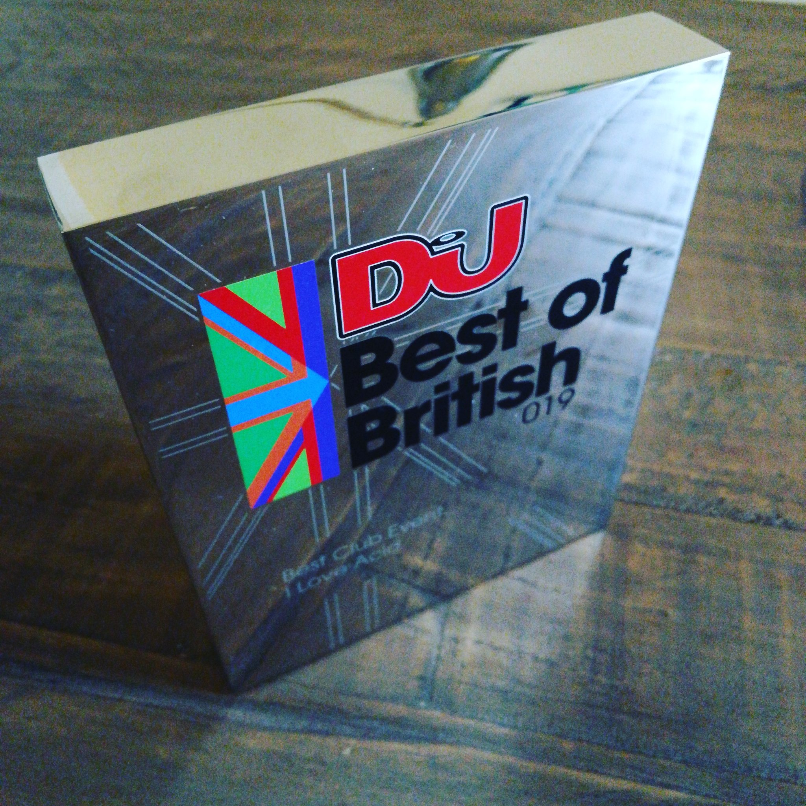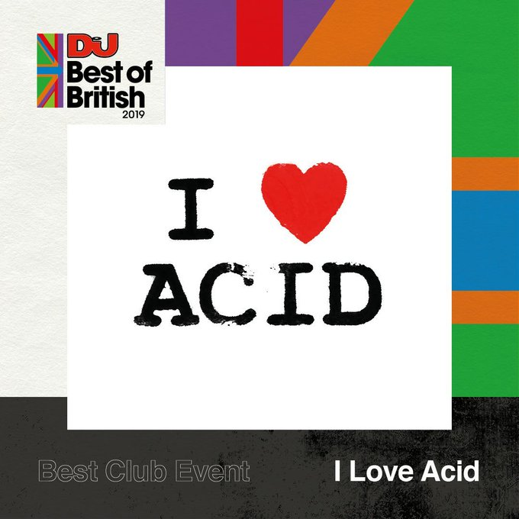

Press:
On Cue interview & mix for DJ Mag
https://djmag.com/features/cue-posthuman
I Love Acid 15th birthday tour on Resident Advisor
https://ra.co/news/77885

Real life stories from the underground on DJ Mag
https://djmag.com/content/real-life-underground-dj

Juno Daily – Label Focus on I Love Acid
https://www.juno.co.uk/junodaily/2021/05/07/label-focus-balkan-vinyl-i-love-acid/

True Underground Acid from off the beaten path for Beatport
https://www.beatportal.com/feed-beatportal/posthumans-10-true-underground-acid-tracks/
“DX21 Synthesizer” article on DJ Mag
https://djmag.com/content/why-yamaha-dx21-posthumans-go-synth

“My Studio” article on Attack Magazine
https://www.attackmagazine.com/features/my-studio/posthuman-2/
Mutant City Acid album announcement on FACT Magazine
https://www.factmag.com/2018/10/15/posthuman-new-album-mutant-city-acid/
“Is Dance Music Too Middle Class?” article on DJ Mag
https://djmag.com/content/dance-music-too-middle-class
30 Years of Acid article on Attack Mag
http://www.attackmagazine.com/features/you-just-have-move-your-feet-30-years-acid/

Modern Acid Classics on Electronic Groove
http://www.electronicgroove.com/posthuman-shares-their-modern-acid-classics/
“It’s a House Thing” interview on Kultur Mag (2016)
http://titel-kulturmagazin.net/2016/09/10/its-a-house-thing-an-interview-with-posthuman/

Interview with Magazine Sixty (2018)
http://www.magazinesixty.com/posthuman-qa/

DJ Mixes & Radio
Rinse FM mix & interview with Shadow Child
https://soundcloud.com/rinsefm/shadowchild111120

Rinse France Balkan Vinyl takeover with Elisa Bee
https://soundcloud.com/rinse_france/balkan-takeover-posthuman-elisa-bee-26-aout-2020

Crack Magazine Mix
https://crackmagazine.net/article/mixprofile/posthuman

Groove Magazine mix
https://soundcloud.com/groove-magazin/bang-face-2020-mix-by-posthuman-bang-face-is-for-the-hardest-people

Bangface takeover, Rinse FM
https://soundcloud.com/rinsefm/posthuman230219

4 hour label exclusive mix for FACT Magazine
http://www.factmag.com/2018/05/08/posthuman-fact-mix/
Solid Steel “30 Years of Acid” show
https://soundcloud.com/ninja-tune/solid-steel-radio-show-11-4-1/
Boiler Room Upfront Mix
https://soundcloud.com/platform/upfront-049-i-love-acid
Red Bull Music Academy ‘Trainwreck’ Mix
https://www.rbmaradio.com/shows/train-wreck-mix/episodes/posthuman

Posthuman & Jerome Hill on Rinse FM
https://soundcloud.com/rinsefm/iloveacid160915

Flux Podcast 102
https://soundcloud.com/flux-music/flux-podcast-102-posthuman
DABJ takeover on Project Radio
https://soundcloud.com/projectbrand/posthuman-dabj-takeover
Video / Streams
Stream The Scene DJ & live set, Summer 2020
https://streamthescene.net/_streams/i-love-acid-17-10-20/
Boiler Room, Manchester 2017
https://www.youtube.com/watch?v=4MhFofG9Jyc&t=2400s

“Against the Clock” for FACT Magazine
http://www.factmag.com/2017/08/16/posthuman-against-the-clock/
“How To Run a Vinyl Only Label” Point Blank lecture on DJ Mag
https://djmag.com/pointblank/industry-insights-how-run-vinyl-only-record-label-i-love-acid

Live at Moog Club, Barcelona 2015
https://www.youtube.com/watch?v=dx3UUR1xhe0

Live at World Unknown, London 2016
https://www.youtube.com/watch?v=4NUDrKn32WM

Live at I Love Acid vs Downfall, London 2017
https://www.youtube.com/watch?v=lGEtgZOB9wE

